
CS-4032: WEB PROGRAMMING
Assignment 02

2D Cricket Web Application

Name: Mustafa Ahsan Khan
Section: CS(6A)
Roll no: 23i-0549

1. Application Overview
Cricket Bash 2D is a single-player 2D cricket batting game built with React and HTML5 Canvas. The player acts as a batsman and plays shots using a probability-based power bar system. The outcome of each ball is determined entirely by where a moving slider stops on the power bar — no random number generation is used for game outcomes.

1.1 Technologies Used
- React 18 — UI components, state management (useState, useEffect, useRef, useCallback)
- Vite 5 — development server and build tool (npm run dev)
- HTML5 Canvas 2D API — all game graphics and animations drawn imperatively
- CSS — styling for all DOM-based UI panels
- JSX — React component syntax for UI structure

1.2 Rendering Architecture
The application uses two rendering approaches:
- Canvas Rendering: The cricket pitch, batsman sprite, bowler sprite, stumps, ball, crowd, stands, and all animations are drawn using the Canvas 2D API in canvasRenderer.js. A requestAnimationFrame loop redraws the scene at 60fps.
- DOM Rendering: The power bar, scoreboard, controls, commentary, ball history, and game-over screen are all React components rendered as HTML elements with CSS styling.

2. Probability-Based Power Bar System
The core mechanic of the game is a deterministic probability system. The power bar is divided into colored segments, each proportional in width to its assigned probability. A slider moves continuously across the bar. When the player clicks PLAY SHOT, the slider position is captured and compared against cumulative segment boundaries to determine the outcome.

2.1 How Outcome Is Determined
The getOutcome() function in App.jsx implements this logic:
function getOutcome(style, sliderPos) {
let cumulative = 0;
for (const seg of PROBS[style]) {
cumulative += seg.prob;
if (sliderPos <= cumulative) return seg;
}

Example: If sliderPos = 0.32 in Aggressive mode, cumulative reaches 0.40 at the Wicket segment, so 0.32 <= 0.40 — result is Wicket.
Example: If sliderPos = 0.88 in Aggressive mode, cumulative reaches 0.85 at the 4-run segment and 1.00 at the 6-run segment, so 0.88 falls in the 6-run zone — result is SIX.

2.2 Defensive Batting Probabilities
Defensive Style (Low Risk, Low Reward)
Outcome | Probability | Bar Width | Risk Level
Wicket | 0.15 | 15% | Low
0 Runs | 0.30 | 30% | —
1 Run | 0.25 | 25% | —
2 Runs | 0.15 | 15% | —
3 Runs | 0.07 | 7% | —
4 Runs | 0.06 | 6% | Low
6 Runs | 0.02 | 2% | Low
TOTAL | 1.00 | 100% | —

2.3 Aggressive Batting Probabilities
Aggressive Style (High Risk, High Reward)
Outcome | Probability | Bar Width | Risk Level
Wicket | 0.40 | 40% | High
0 Runs | 0.10 | 10% | —
1 Run | 0.10 | 10% | —
2 Runs | 0.10 | 10% | —
3 Runs | 0.05 | 5% | —
4 Runs | 0.10 | 10% | High
6 Runs | 0.15 | 15% | High
TOTAL | 1.00 | 100% | —

2.4 Comparison: Defensive vs Aggressive
Metric | Defensive | Aggressive
Wicket Risk | 15% | 40%
Boundary Probability | 8% | 25%
Safe Zone (0-2 runs) | 70% | 30%

3. Animation System
All animations run via requestAnimationFrame loops. Animation state is stored in useRef (not useState) to avoid triggering React re-renders at 60fps.

3.1 Bowling Animation
When the player clicks PLAY SHOT, the slider position is captured immediately from sliderStateRef.current.pos. The slider stops and the bowling animation begins:
- Ball spawns at the bowler position on the right side of the canvas (BOWL_START_X = 565, BOWL_START_Y = 196)
- Ball travels left toward the batsman (BOWL_END_X = 168, BOWL_END_Y = 212) over 650ms
- A pitch-bounce effect is applied using: bounce = Math.sin(t * PI * 1.5) * 22
- The sine curve dips the ball downward around t=0.33, simulating the ball hitting the pitch

3.2 Bat Swing Animation
After the ball reaches the batsman, the bat swing animation begins (320ms):
- On a hit (runs > 0): bat rotates forward with batSwing = Math.sin(t * PI) * 1.4
- On a miss/dot/wicket: small defensive push batSwing = -Math.sin(t * PI) * 0.3
- If a hit, ball flies away from t=0.35 onward: ballX += flyT * 380, ballY -= flyT * 180
- Animation completes, bat resets to 0, applyOutcome() is called with the captured outcome

3.3 Why useRef for Animation State
Ball position (ballX, ballY) and bat angle (batSwing) are stored in animRef (useRef), not useState. This is because React state updates are asynchronous and would cause 60 re-renders per second if used inside a requestAnimationFrame loop, severely degrading performance. The canvas loop reads animRef.current directly each frame without triggering any React re-render.

4. Gameplay Screenshots
The following screenshots demonstrate the application in various game states. Each screenshot has a sticky note visible as required by the assignment.

Screenshot 1: Aggressive Batting in Action
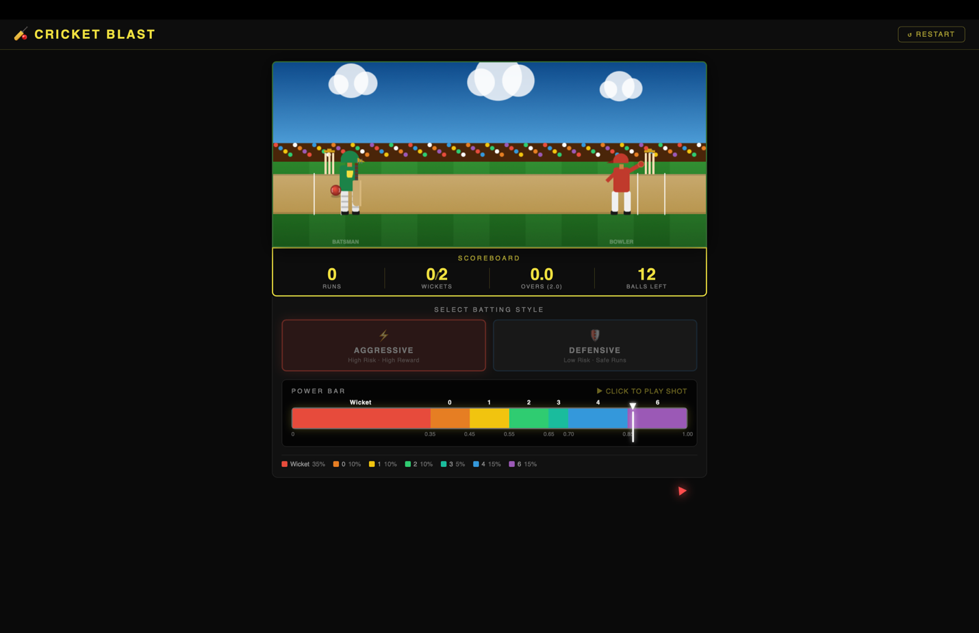

Screenshot 2: Defensive Batting in Action
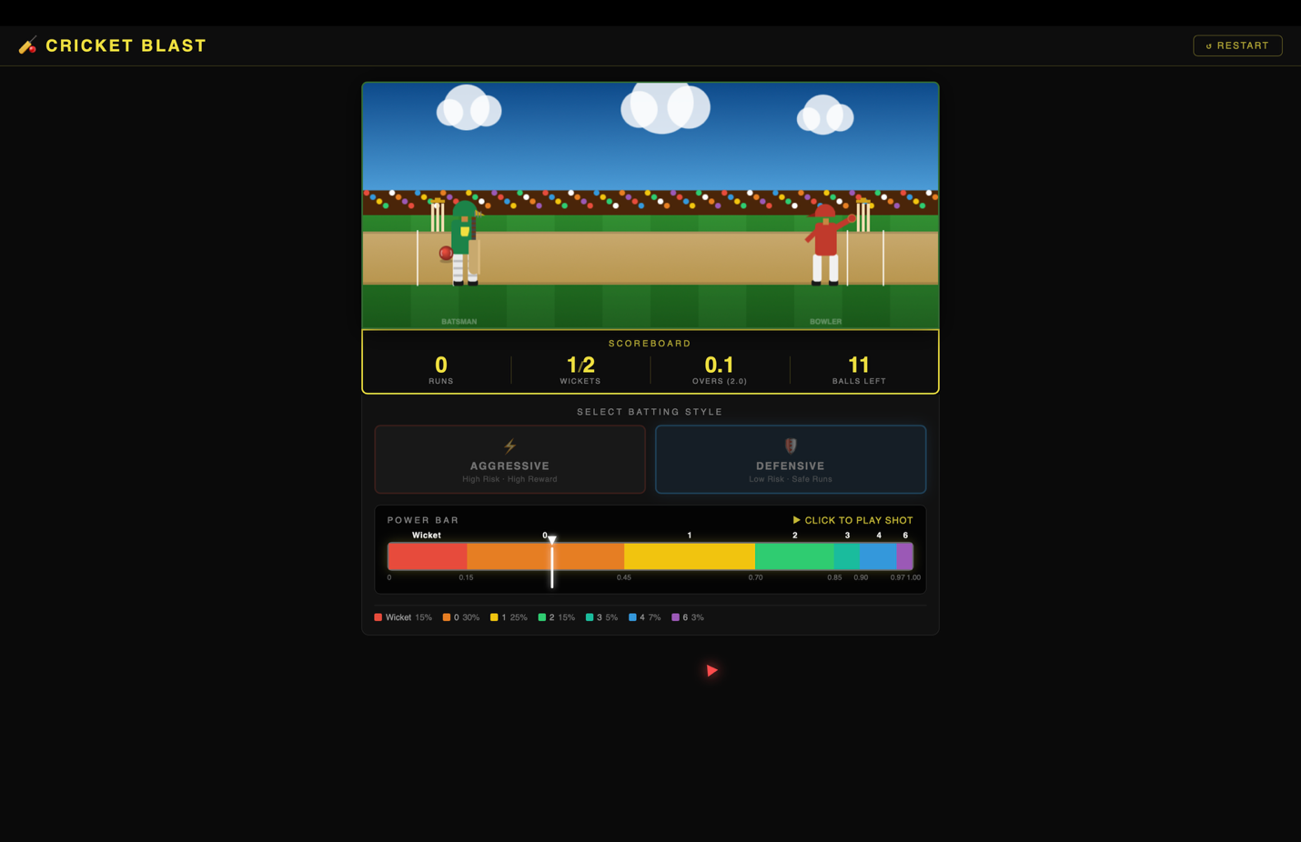

Screenshot 3: Power Bar During Gameplay


Screenshot 4: Scoreboard Updates


5. Project Structure
File | Purpose
App.jsx | Root component — game state, slider loop, animation orchestration
constants.js | Probability tables, commentary bank, game config, initial state
canvasRenderer.js | All Canvas 2D drawing — pitch, sprites, ball, stumps, animations
components/PowerBar.jsx | DOM probability bar with proportional segments and slider
components/Scoreboard.jsx | Live match statistics display
components/Controls.jsx | Batting style buttons, Play Shot, Restart
components/BallHistory.jsx | Per-ball colour-coded history dots
components/OverConfig.jsx | Configurable overs selector (1/2/3 overs)
components/GameOverlay.jsx | Full-screen game over screen
components/ResultFlash.jsx | Animated result pop-up on canvas

6. Bonus Features Implemented

6.1 Dynamic Commentary System
The COMMENTARY object in constants.js stores 4-5 hardcoded lines per outcome. After each delivery, pickComment() randomly selects one line and displays it with colour-coding: red for wickets, gold for boundaries.

6.2 Configurable Overs
The OverConfig component allows the player to select 1, 2, or 3 overs before the innings begins. The selection updates configBalls in React state which controls the total balls available.

6.3 Ball-by-Ball History
The BallHistory component renders a row of coloured dots — one per ball. Each dot shows the run value and is colour-coded: red = wicket, grey = dot, green = 1-3 runs, orange = 4, purple = 6. Dots are grouped by over with a divider line.

6.4 Probability Sum Validator
The PowerBar component calculates the sum of all probabilities and displays it as Sigma = 1.00 with a green tick. This confirms both batting styles have valid probability distributions that sum exactly to 1.

